

# **Data Communication & Computer Networks Lab**

**Submitted by: Submitted to:**

**NAME : Rahul Gusain**

**SAP : 500084143**

**ROLL NO. : R214220900 Ved Prakash Bhardwaj**

**BATCH: 1 DevOps**

**LAB FILE**

**INDEX**

| **S.no** | **Experiments** | **Remarks** |
| --- | --- | --- |
| 1 | Familiarization of Network devices |  |
| 2 | Write a program for Bit stuffing and Destuffing in a bit stream |  |
| 3 | Familiarization of Transmission media |  |
| 4 | Write a program for CRC and Hamming code |  |
| 5 | Simulation using Packet Tracer with help of Switch |  |
| 6 | Simulation using Packet Tracer with help of router |  |
| 7 | Set –up the network topology using two routers on Packet tracer |  |
| 8 | Set –up the network topology using more than two routers on Packet tracer |  |
| 9 | Familiarization of Network IP & Subnetting & super netting |  |

**EXPERIMENT 1**

**Familiarization of Network devices**

**REPEATER:** A repeater is a network device that retransmits a received signal with more power and to an extended geographical or topological network boundary than what would be capable with the original signal.

A repeater is implemented in computer networks to expand the coverage area of the network, repropagate a weak or broken signal and or service remote nodes. Repeaters amplify the received/input signal to a higher frequency domain so that it is reusable, scalable and available.

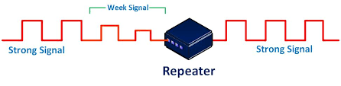

**HUB:** A hub is a common connection point, also known as a network hub, which is used for the connection of devices in a network. It works as a central connection for all the devices that are connected through a hub. The hub has numerous ports. If a packet reaches one port, it is able to see all the segments of the network due to a packet being copied to the other ports. A network hub has no routing tables or intelligence (unlike a network switch or router), which is used to send information and broadcast all network data across each and every connection.

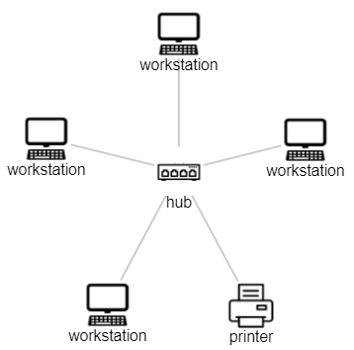

**SWITCH:** A switch is a multiport bridge with a buffer and a design that can help it function better (a large number of ports indicate less traffic). A switch is a data connection layer device. Before forwarding data, the switch may check for faults, which makes it extremely efficient because it doesn't transport packets with errors and only forwards good packets to the correct port. To put it another way, the switch separates hosts' collision domains while maintaining the broadcast domain

.

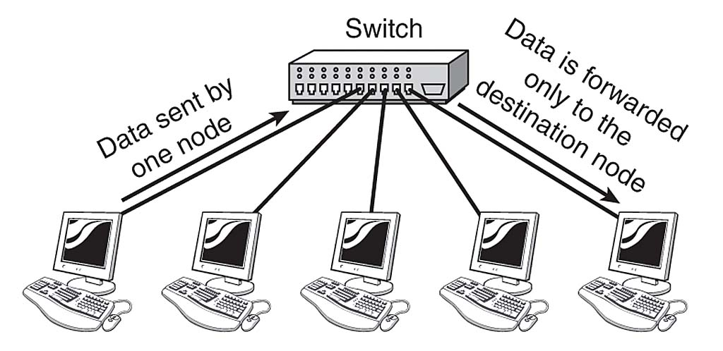

**ROUTER:** In the same way that switches route data packets based on their IP addresses, routers do the same. The router is basically a device that performs network layer functions. Routers connect LANs and WANs and decide how to route data packets using a dynamically updated routing table. The router divides the broadcast domains of hosts connected through it.

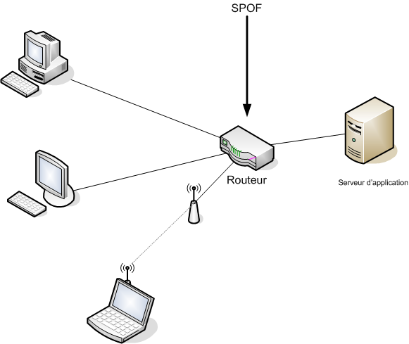

**BRIDGE:** A data connection layer device is referred to as a bridge. A bridge is a repeater that also has the capacity to filter data by reading the source and destination MAC addresses. It may also be used to connect two LANs using the same protocol. Because it only has one input and output port, it is a two-port device.

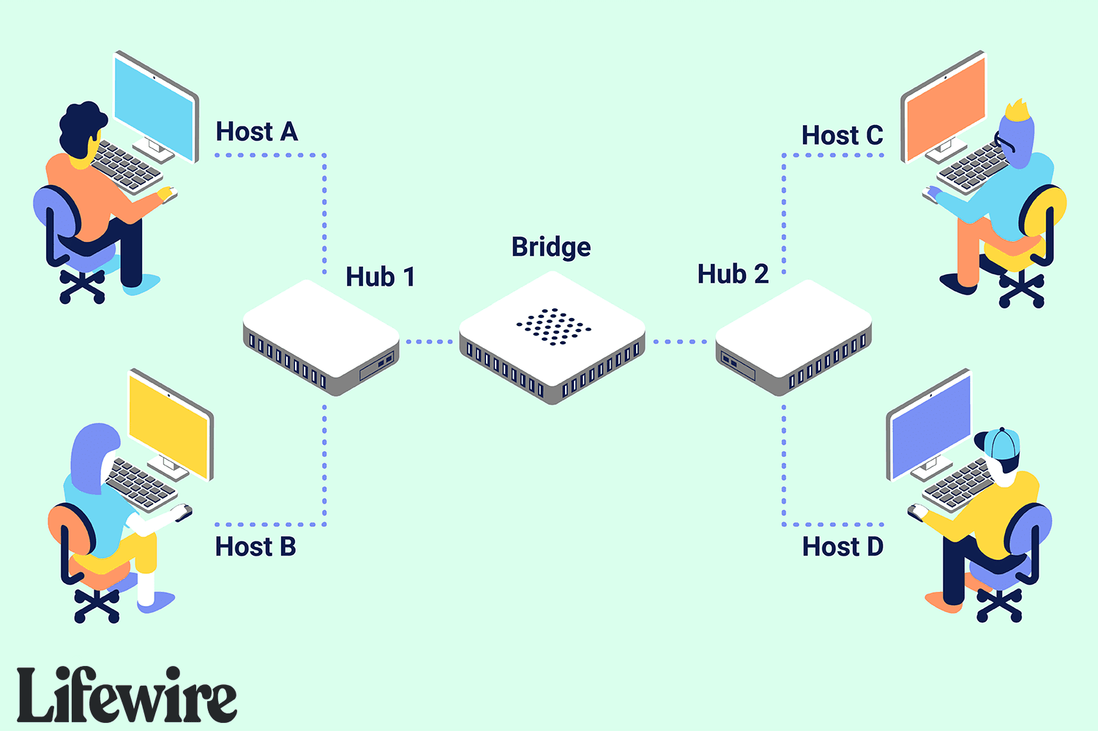

**GATEWAY:** A gateway is basically a device or hardware which acts as a “gate” among the networks. Thus it can also be defined as a node that acts as an entrance for the other nodes in the network. It is also responsible for enabling the traffic flow within the network. Gateway uses more than one protocol for communication thus its activities are much more complex than a switch or a router.

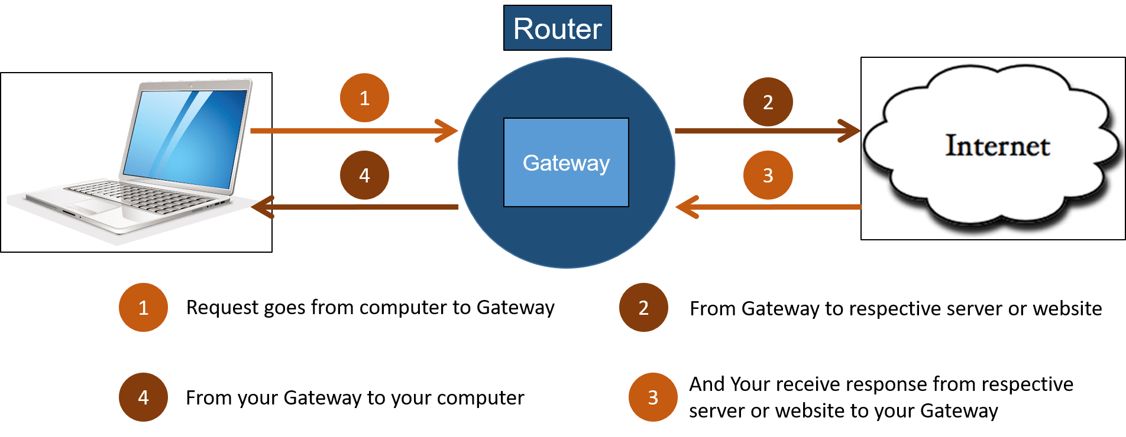

**EXPERIMENT 2**

**Write a program for Bit stuffing and Destuffing in a bitstream.**

​​Bit stuffing is the insertion of non-information bits into data. Note that stuffed bits should not be confused with overhead bits. Overhead bits are non-data bits that are necessary for transmission (usually as part of headers, checksums etc.).

Algorithm:

Stage 1-Create a 3 single cluster of adequate size

Stage 2-For Bit Stuffing: Create 2 single type pointer variable highlighting the principal component of information and stuff exhibit.

Stage 3-Traverse the information exhibit till last component.

Stage 4-Create an if condition to actually take a look at the component in string; in the event that the component is '0' store it in *y and increase the pointer variable.

Stage 5-If the component found isn't '0' then in else condition make some time circle which will run till *x is '1' and counter factor isn't 5 and afterward increase counter and store *x variable in *y variable and augmentation x and y.

Stage 6-is count=5 then store '0' at that record after which 5 sequential 1 happens and increase y. Store it in *y pointer variable.

Stage 7-For Bit Destuffing; x=stuff and y=destuff

Stage 8-All the means would be same as we did in stiffing other than the last advance rather than putting away '0' in the stuff exhibit just addition the pointer variable.

**Code-**

#include<stdio.h>

#include<stdlib.h>

int main()

{

char temp;

char input[100];

char stuff[100];

char *x,*y;

char destuff[100];

int count=0;

printf("enter the input character string \n");

scanf("%s",input);

// for Bit Stuffing

x=input;

y=stuff;

while(*x!='\0')

{

if(*x=='0')

{

*y=*x;

y++;

x++;

}

else

{

while(*x=='1' && count!=5)

{

count++;

*y=*x;

y++;

x++;

}

if(count==5)

{

*y='0';

y++;

}

count=0;

}

}

*y='\0';

printf("\nBit stuffed string is");

printf("\n%s",stuff);

// for Bit Destuffing and taking the value of x from y of stuffing part

x=stuff;

y=destuff;

while(*x!='\0')

{

if(*x=='0')

{

*y=*x;

y++;

x++;

}

else

{

while(*x=='1' && count!=5)

{

count++;

*y=*x;

y++;

x++;

}

if(count==5)

{

x++;

}

count=0;

}

}

*y='\0';

printf("\nThe destuffed string is");

printf("\n%s\n",destuff);

printf("\n\nRahul Gusain\n");

printf("SAP ID: 500084143");

return 0;

}

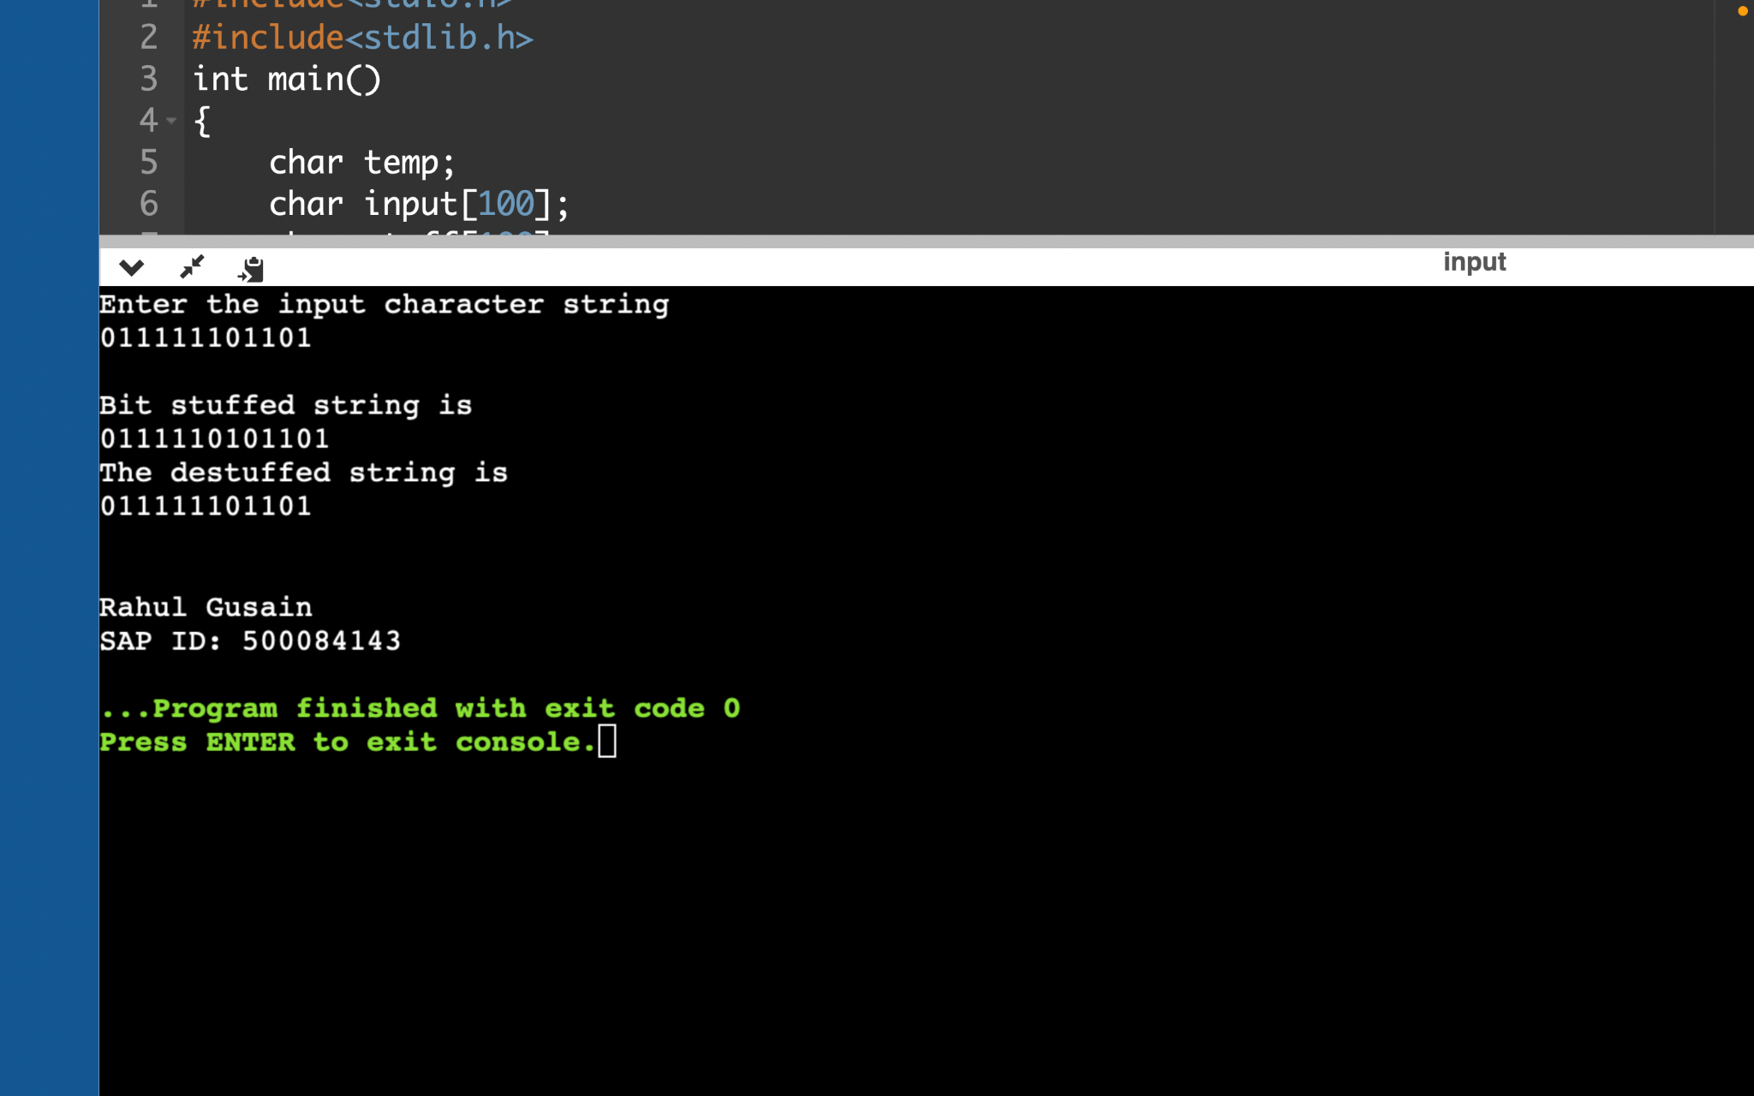

**EXPERIMENT 3**

Familiarization of Transmission media

**Aim:** Study in detail the following transmission media in computer networks:

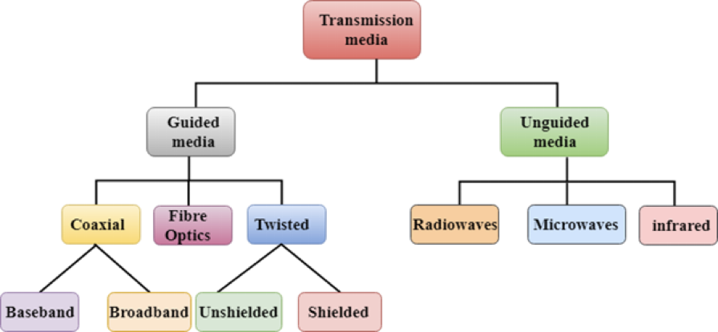

**Apparatus (Software):** No Software or hardware is needed.

**Theory:** Transmission media is a communication channel that transmits information from sender to receiver. Data is transmitted through electromagnetic signals. There are two types of transmission media, wired media and wireless media. In wired media, the medium characteristics are more important, whereas, in wireless media, the signal characteristics are more important. Different transmission media have different properties such as bandwidth, delay, cost and ease of installation and maintenance. The transmission media is available in the physical layer- the lowest layer of the OSI reference model.

**Procedure:** Explain each transmission medium in detail with a suitable diagram. Also, write a short note on each transmission medium.

**Conclusion:** Gain knowledge about transmission media in computer networks.

The transmission medium can be defined as a pathway that can transmit information from a sender to a receiver. Transmission media are located below the physical layer and are controlled by the physical layer. Transmission media are also called communication channels.

Transmission media are of two types −

* Guided Transmission Medium
* Unguided Transmission Medium

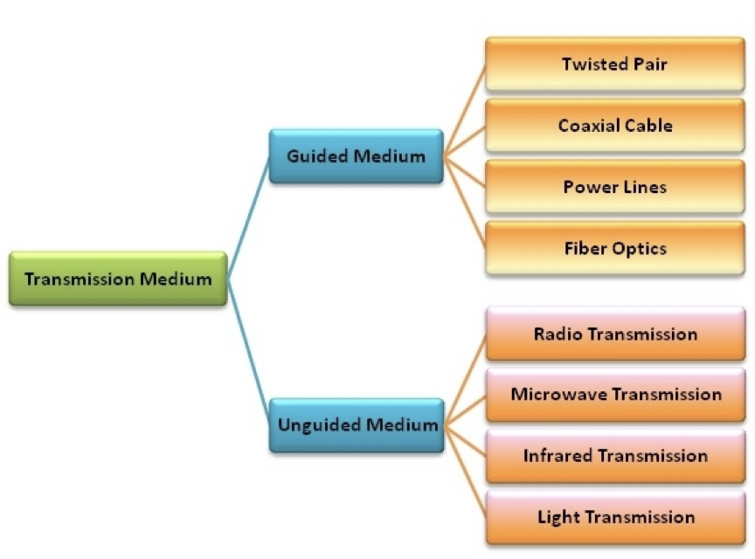

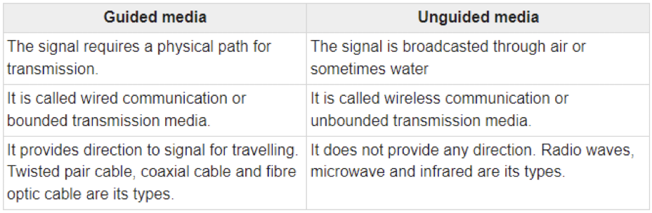

**Guided Transmission Medium**

Guided transmission media are also called bounded media or wired media. They comprise cables or wires through which data is transmitted. They are called guided since they provide a physical conduit from the sender device to the receiver device. The signal travelling through these media are bounded by the physical limits of the medium.

The most popular guided media are −

* Twisted pair cable
* Coaxial cable
* Power lines
* Fibre optics

**Twisted Pair Copper**

It is the most used media across the world. All the local telephone exchanges are made of twisted-pair copper. These telephone lines are reused as last-mile DSL access links to access the internet from home.

Twisted pair copper wires are also used in Ethernet LAN cables within homes and offices.

It supports low to High Data Rates which is in the order of Gigabytes.

These wires are effective up to a maximum distance of a few kilometres/miles, because the signal strength is lost significantly beyond the distance.

Generally, they come in two variants as follows −

* UTP (unshielded twisted pair)
* STP (shielded twisted pair)

For every variant, there are multiple sub-variants, based on the thickness of the material (like UTP-3, UTP-5, UTP-7 etc.)

The twisted-pair copper is diagrammatically represented as follows −

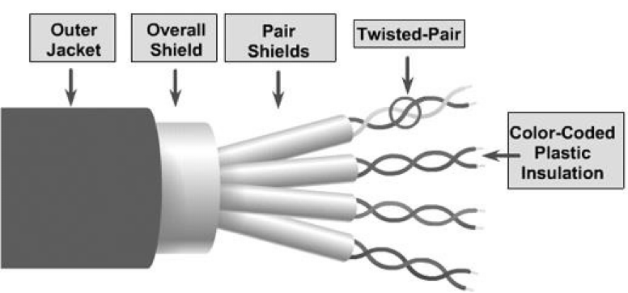

**Copper Co-axial Cables**

Co-axial copper cables consist of an inner copper conductor and an outer copper shield, which are separated by a dielectric insulating material, helpful in preventing signal losses.

Copper co-axial cables are used in cable TV networks and as trunk lines between telecommunication equipment.

It serves as an internet access line from the home and supports medium to high data rates.

The copper co-axial cable is diagrammatically represented as follows −

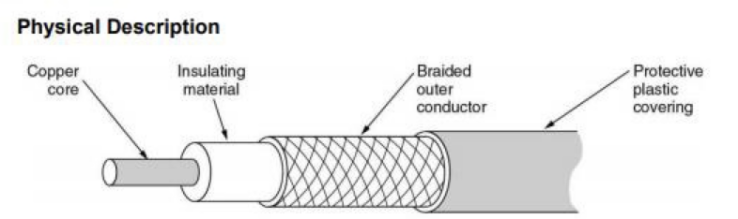

**Fibre Optic Cables**

In fibre optic cables the information is transmitted by the propagation of optical signals (light) fibre optic cables and not through electrical/electromagnetic signals. Because of this, fibre optics communication supports longer distances as there is no electrical interference.

The fibre optic cables are made of very thin strands of glass (silica). It supports high data rates.

It is used for accessing the internet from home through FTTH (Fiber-To-The-Home) lines.

Examples − OC-48, OC-192, FTTC, HFC.

The fibre optic cable is diagrammatically represented as follows –

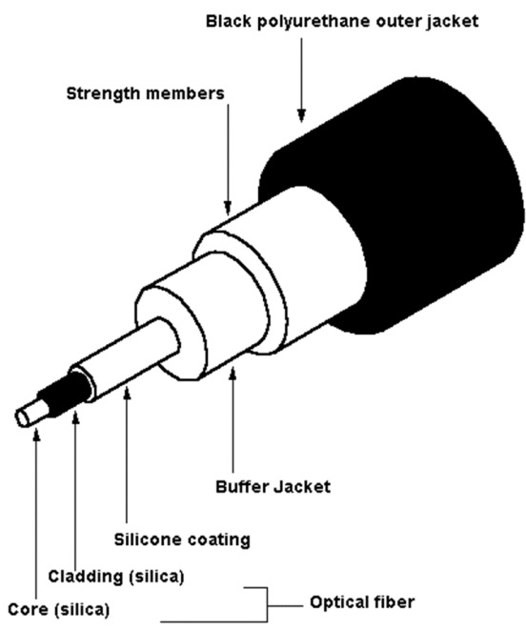

**Unguided Transmission Medium**

Unguided transmission media are also called wireless media. They transport data in the form of electromagnetic waves that do not require any cables for transmission. These media are bounded by geographical boundaries. This type of communication is commonly referred to as wireless communications.

Unguided signals can travel in three ways −

* Ground propagation
* Sky propagation
* Line–of–sight propagation

The commonly used unguided transmissions are −

* Radio transmission
* Microwave transmission
* Infrared transmission
* Light transmission

**(i) Radio waves –**

These are easy to generate and can penetrate through buildings. The sending and receiving antennas need not be aligned. Frequency Range: 3KHz – 1GHz. AM and FM radios and cordless phones use Radio waves for transmission.

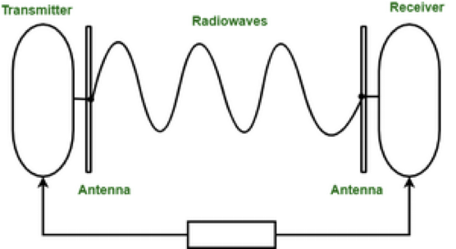

Further Categorized as (i) Terrestrial and (ii) Satellite.

**(ii) Microwaves –**

It is a line of sight transmission i.e. the sending and receiving antennas need to be properly aligned with each other. The distance covered by the signal is directly proportional to the height of the antenna. Frequency Range: 1GHz – 300GHz. These are majorly used for mobile phone communication and television distribution.

The electromagnetic waves having frequencies between 1 and 300 GHz are known as a microwave. Microwave systems use very high-frequency radio or television signals to transmit data through space. Therefore, the transmitter and receiver of a microwaves system, which is mounted on very high towers, should be invisible to each other, i.e., they both should be in a line of sight. Moreover, the signals become weak after travelling a certain distance and require power amplification.

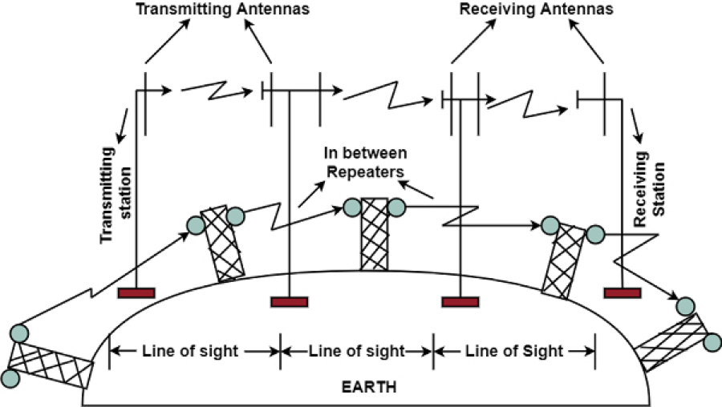

**(iii) Infrared –**

Infrared waves are used for very short distance communication. They cannot penetrate through obstacles. This prevents interference between systems. Frequency Range: 300GHz – 400THz. It is used in TV remotes, wireless mouse, keyboards, printers, etc.

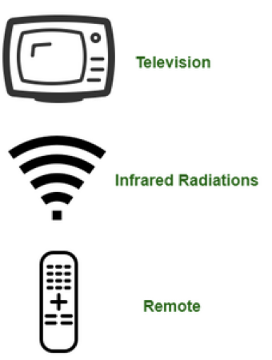

**EXPERIMENT 4**

Aim :- To implement hamming code and CRC

Theory:-

Hamming code is a set of error-correction codes that can be used to detect and correct the errors that can occur when the data is moved or stored from the sender to the receiver. It is a technique developed by R.W. Hamming for error correction

Algorithm:-

1.Number the bits starting from 1: bit 1, 2, 3, 4, 5, 6, 7, etc.

2.Write the bit numbers in binary: 1, 10, 11, 100, 101, 110, 111, etc.

3.All bit positions that are powers of two (have a single 1 bit in the binary form of their position) are parity bits: 1, 2, 4, 8, etc. (1, 10, 100, 1000)

4.All other bit positions, with two or more 1 bits in the binary form of their position, are data bits.

5.Each data bit is included in a unique set of 2 or more parity bits, as determined by the binary form of its bit position.

* 1. Parity bit 1 covers all bit positions which have the **least** significant bit set: bit 1 (the parity bit itself), 3, 5, 7, 9, etc.
  2. Parity bit 2 covers all bit positions which have the **second** least significant bit set: bits 2-3, 6-7, 10-11, etc.
  3. Parity bit 4 covers all bit positions which have the **third** least significant bit set: bits 4–7, 12–15, 20–23, etc.
  4. Parity bit 8 covers all bit positions which have the **fourth** least significant bit set: bits 8–15, 24–31, 40–47, etc.
  5. In general each parity bit covers all bits where the bitwise AND of the parity position and the bit position is non-zero.

If a byte of data to be encoded is 10011010, then the data word (using _ to represent the parity bits) would be __1_001_1010, and the code word is 011100101010.

The choice of the parity, even or odd, is irrelevant but the same choice must be used for both encoding and decoding.

**Code:-**

#include<stdio.h>

void main() {

int data[10];

int dataatrec[10],c,c1,c2,c3,i;

printf("Enter 4 bits of data one by one\n");

scanf("%d",&data[0]);

scanf("%d",&data[1]);

scanf("%d",&data[2]);

scanf("%d",&data[4]);

//Calculation of even parity

data[6]=data[0]^data[2]^data[4];

data[5]=data[0]^data[1]^data[4];

data[3]=data[0]^data[1]^data[2];

printf("\nEncoded data is\n");

for(i=0;i<7;i++)

printf("%d",data[i]);

printf("\n\nEnter received data bits one by one\n");

for(i=0;i<7;i++)

scanf("%d",&dataatrec[i]);

c1=dataatrec[6]^dataatrec[4]^dataatrec[2]^dataatrec[0];

c2=dataatrec[5]^dataatrec[4]^dataatrec[1]^dataatrec[0];

c3=dataatrec[3]^dataatrec[2]^dataatrec[1]^dataatrec[0];

c=c3*4+c2*2+c1 ;

if(c==0) {

printf("\nNo error while transmission of data\n");

}

else {

printf("\nError on position %d",c);

printf("\nData sent : ");

for(i=0;i<7;i++)

printf("%d",data[i]);

printf("\nData received : ");

for(i=0;i<7;i++)

printf("%d",dataatrec[i]);

printf("\nCorrect message is\n");

//if errorneous bit is 0 we complement it else vice versa

if(dataatrec[7-c]==0)

dataatrec[7-c]=1;

else

dataatrec[7-c]=0;

for (i=0;i<7;i++) {

printf("%d",dataatrec[i]);

}

}

}

**Output:-**

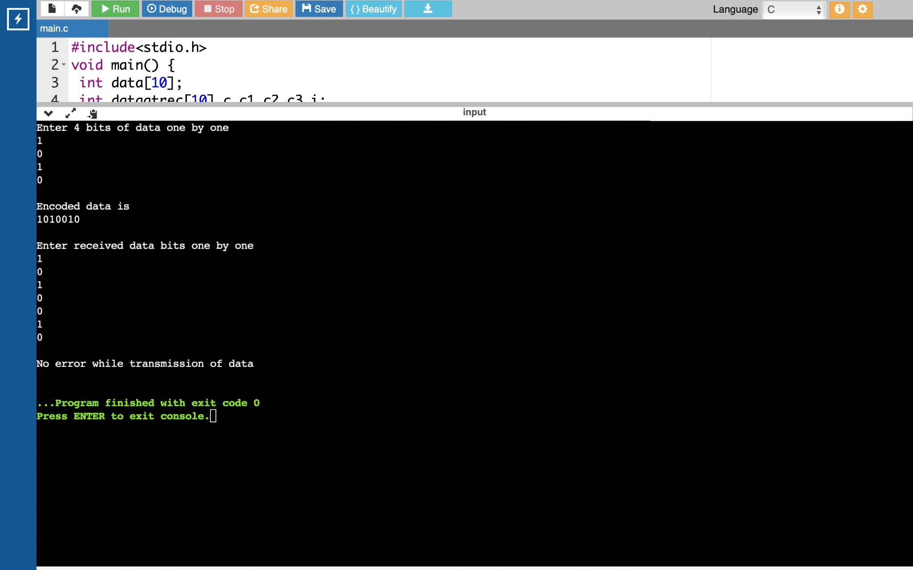

**Code for CRC:-**

#include<stdio.h>

char data[20],div[20],temp[4],total[100];

int i,j,datalen,divlen,len,flag=1;

void check();

int main()

{

printf("Enter the total bit of data:");

scanf("%d",&datalen);

printf("\nEnter the total bit of divisor");

scanf("%d",&divlen);

len=datalen+divlen-1;

printf("\nEnter the data:");

scanf("%s",&data);

printf("\nEnter the divisor");

scanf("%s",div);

for(i=0;i<datalen;i++)

{

total[i]=data[i];

temp[i]=data[i];

}

for(i=datalen;i<len;i++)

total[i]='0';

check(); for(i=0;i<divlen;i++)

temp[i+datalen]=data[i];

printf("\ntransmitted Code Word:%s",temp);

printf("\n\nEnter the received code word:");

scanf("%s",total);

check();

for(i=0;i<divlen-1;i++)

if(data[i]=='1')

{

flag=0;

break;

}

if(flag==1)

printf("\nsuccessful!!");

else

printf("\nreceived code word contains errors...\n");

}

void check()

{

for(j=0;j<divlen;j++)

data[j]=total[j];

while(j<=len)

{

if(data[0]=='1')

for(i = 1;i <divlen ; i++)

data[i] = (( data[i] == div[i])?'0':'1');

for(i=0;i<divlen-1;i++) data[i]=data[i+1];

data[i]=total[j++];

}

}

**Output:-**

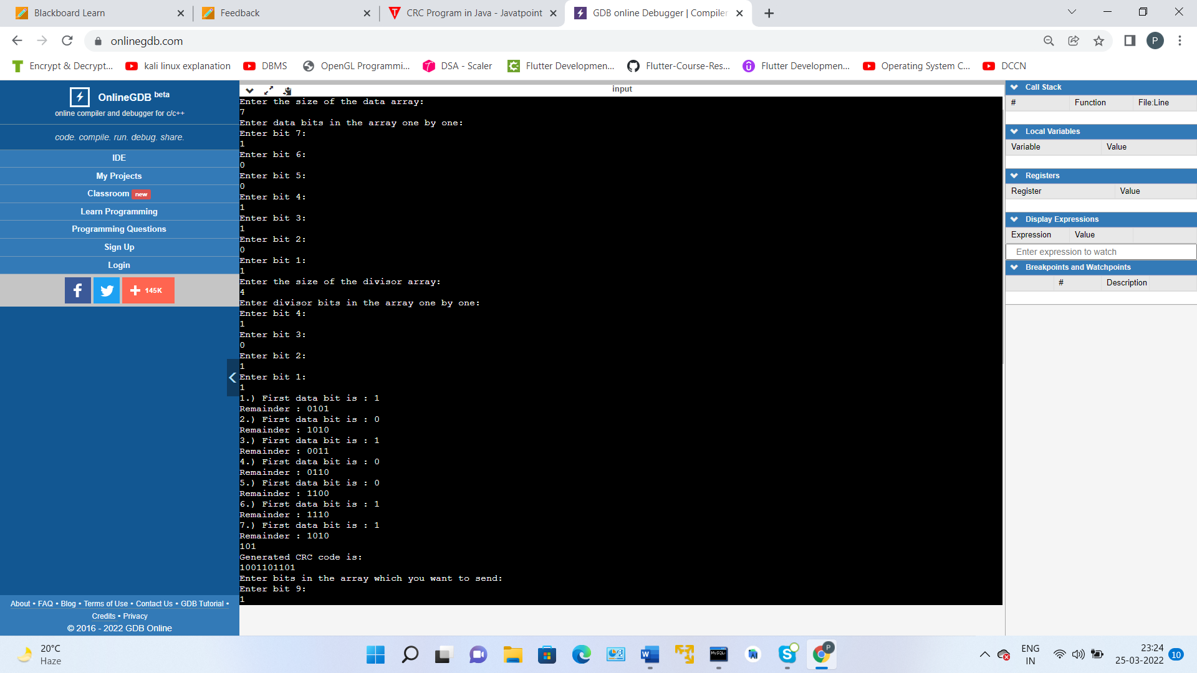

**EXPERIMENT 5**

**Simulation using Packet Tracer with help of Switch**

Download Cisco Packet Tracer

<https://www.netacad.com/courses/packet-tracer>

Screenshots :-



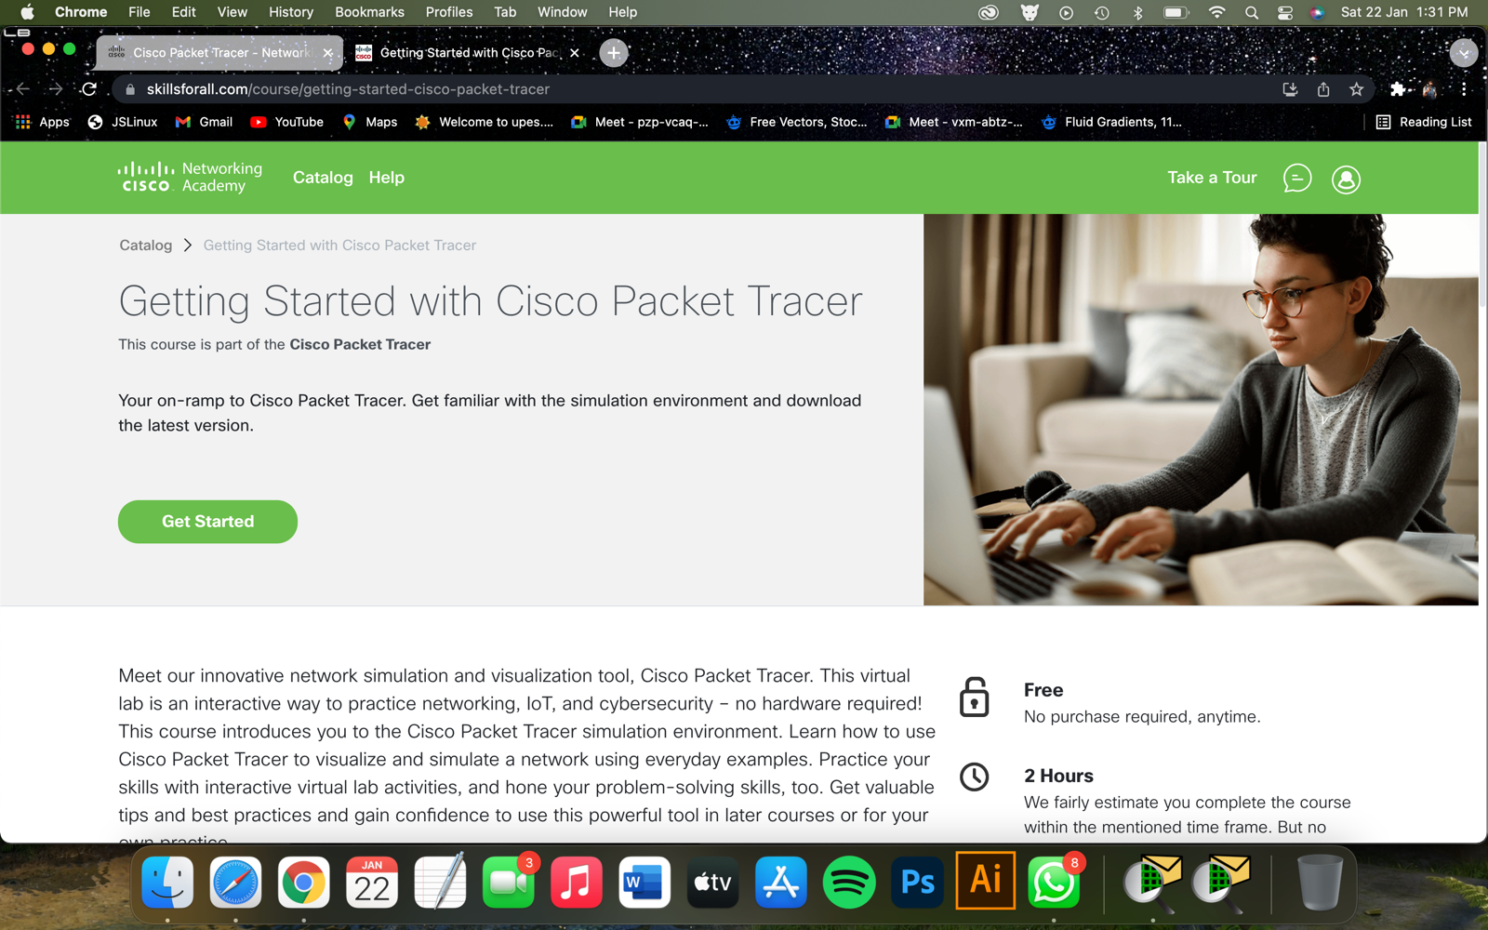

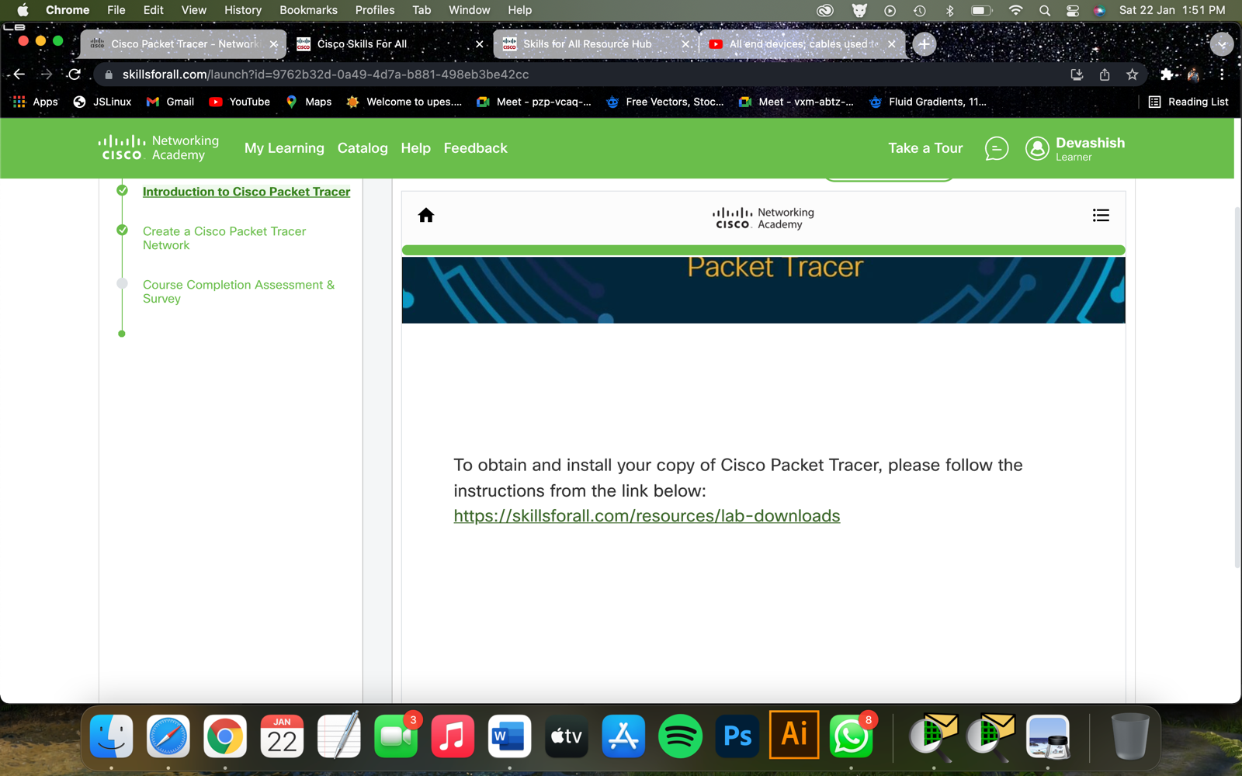

<https://skillsforall.com/resources/lab-downloads>

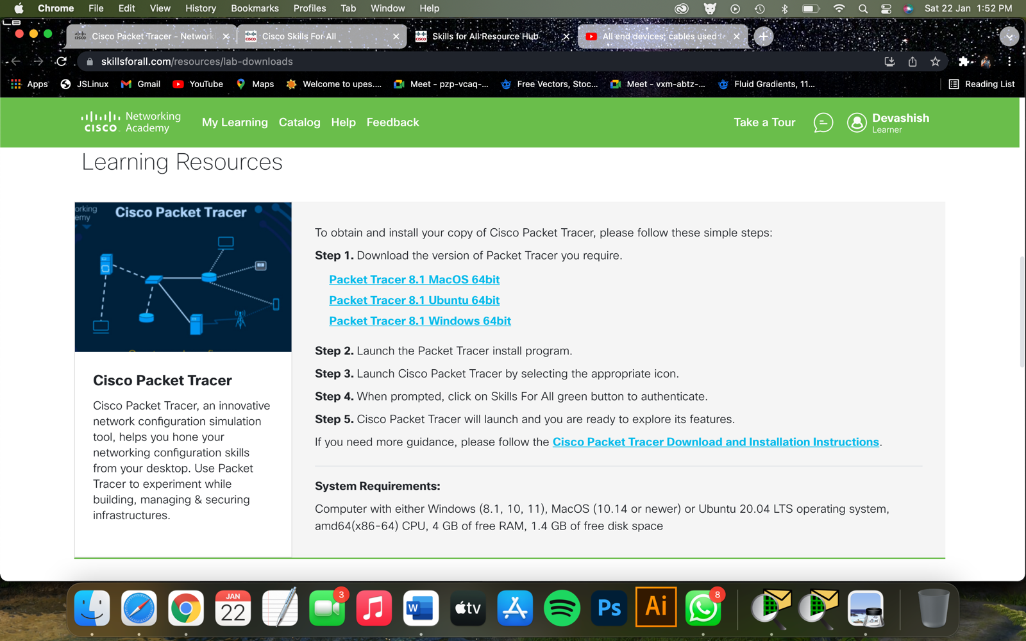

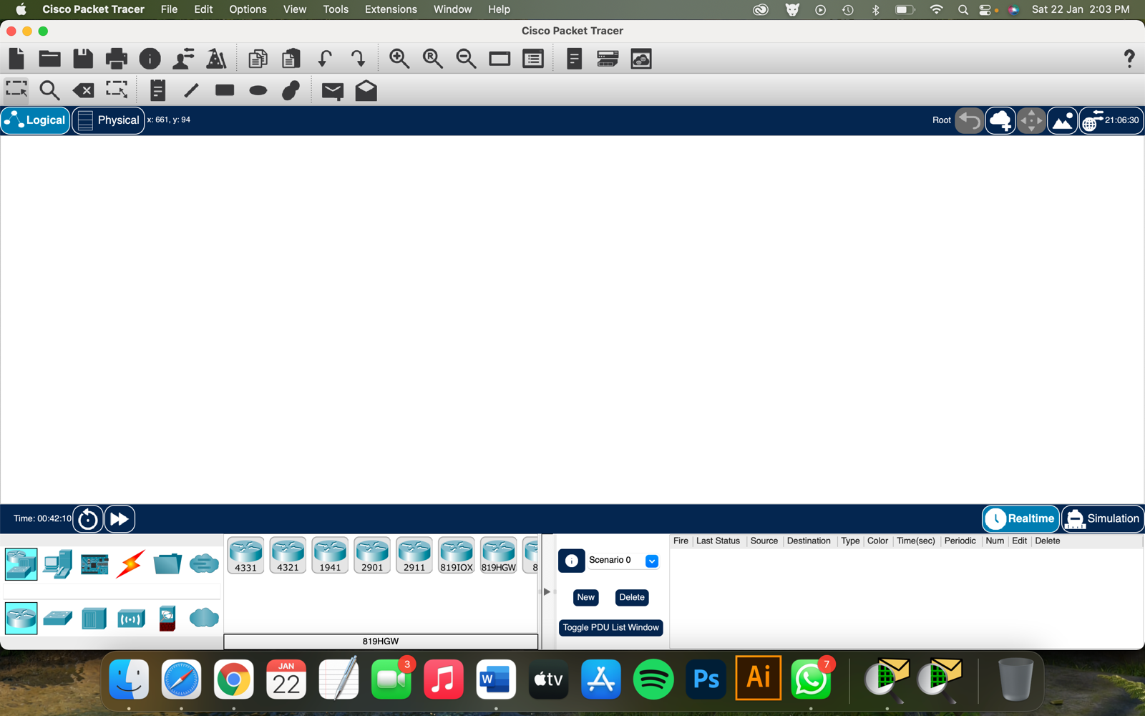

Task 1: Make a connection of 20 PCs using a switch and wires.

Screenshots :-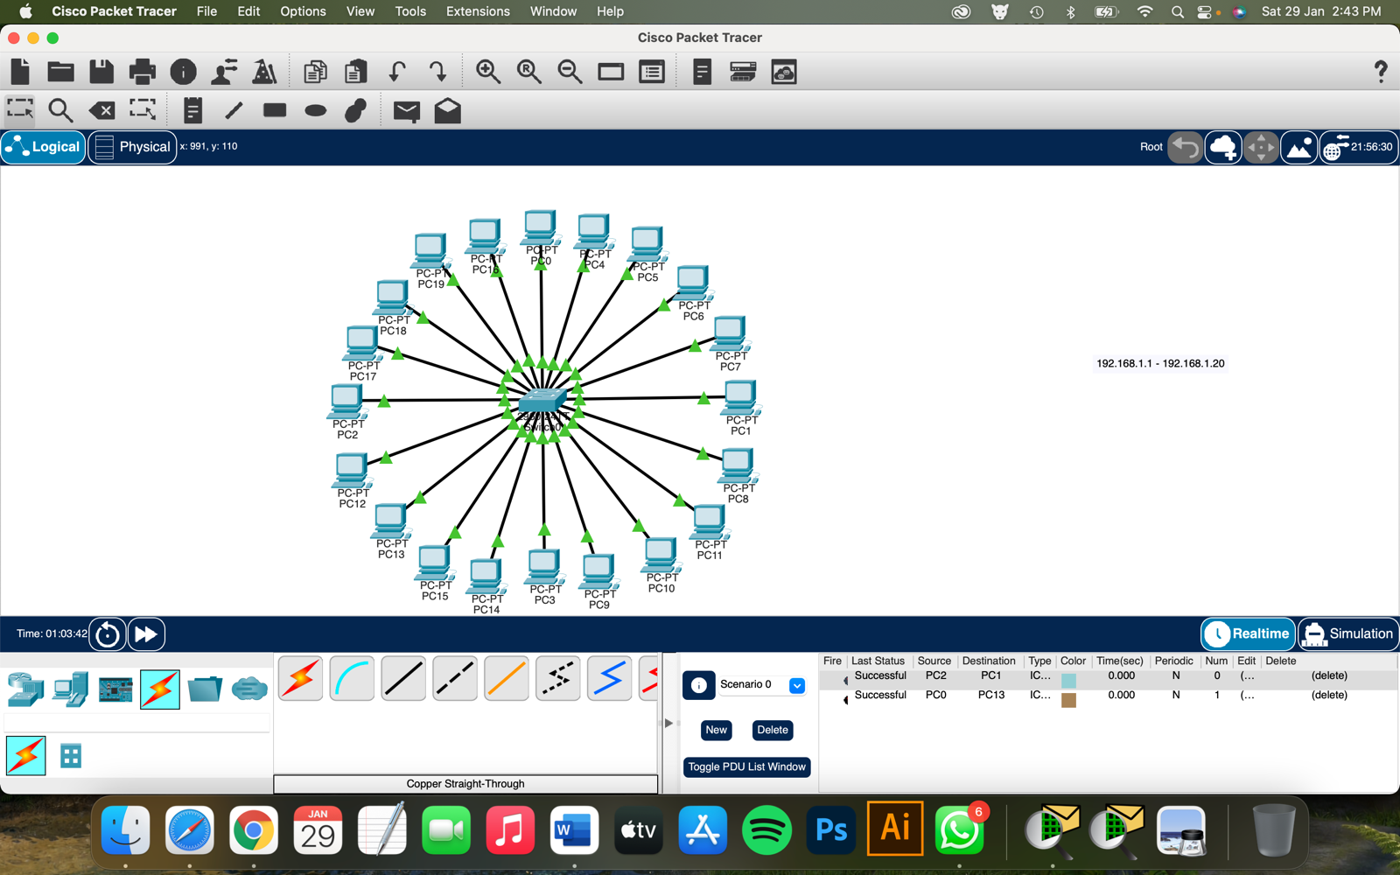

Task 2 : Assign every PC a IP address ranging from 192.168.1.1 to 192.168.1.20

Screenshot:

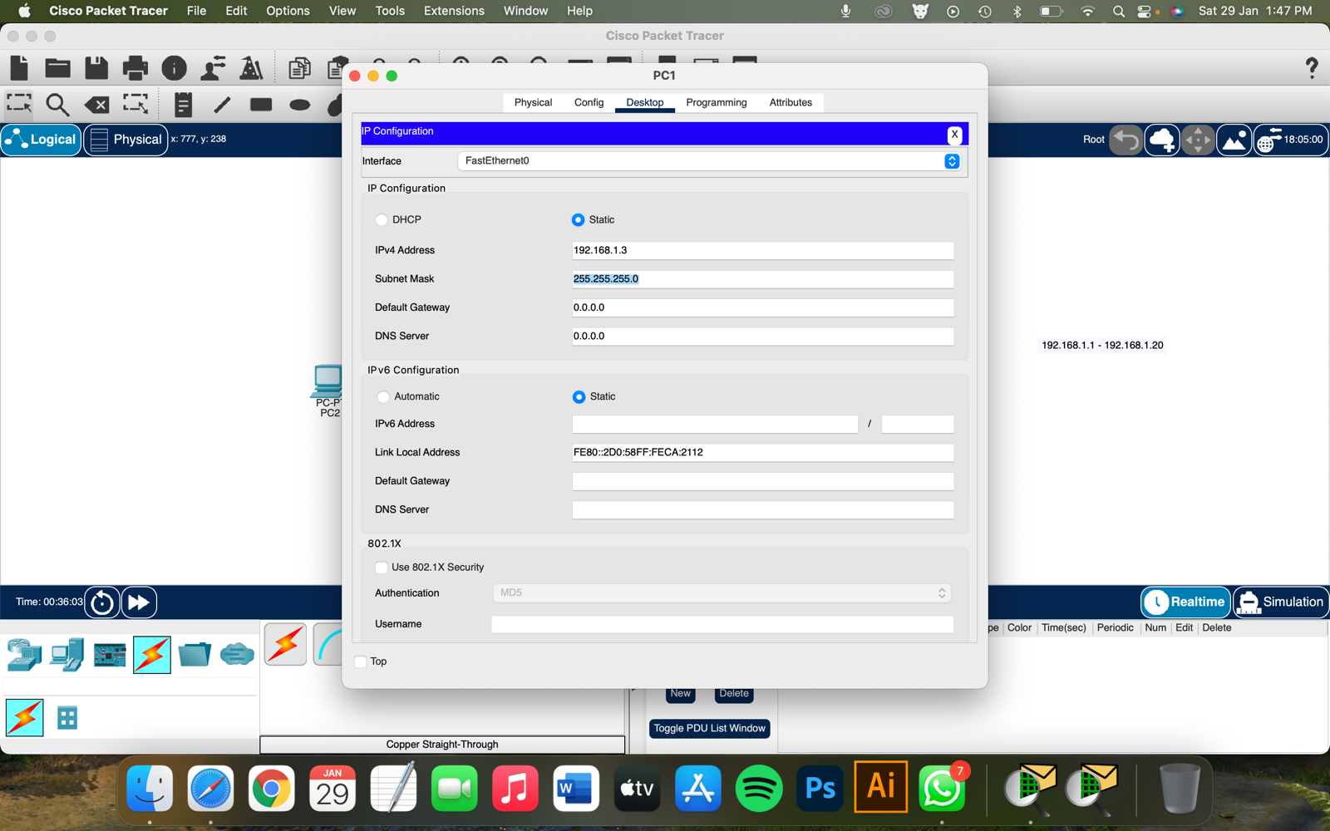

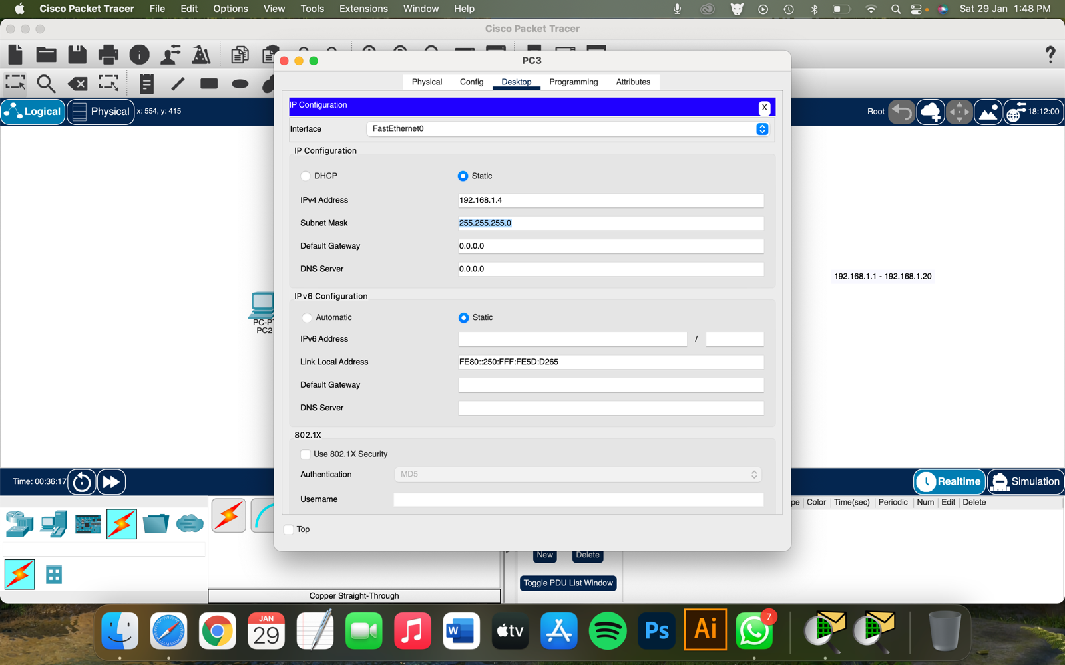

Task 3: Checking the connection by using ping command in cmd prompt

Screenshot: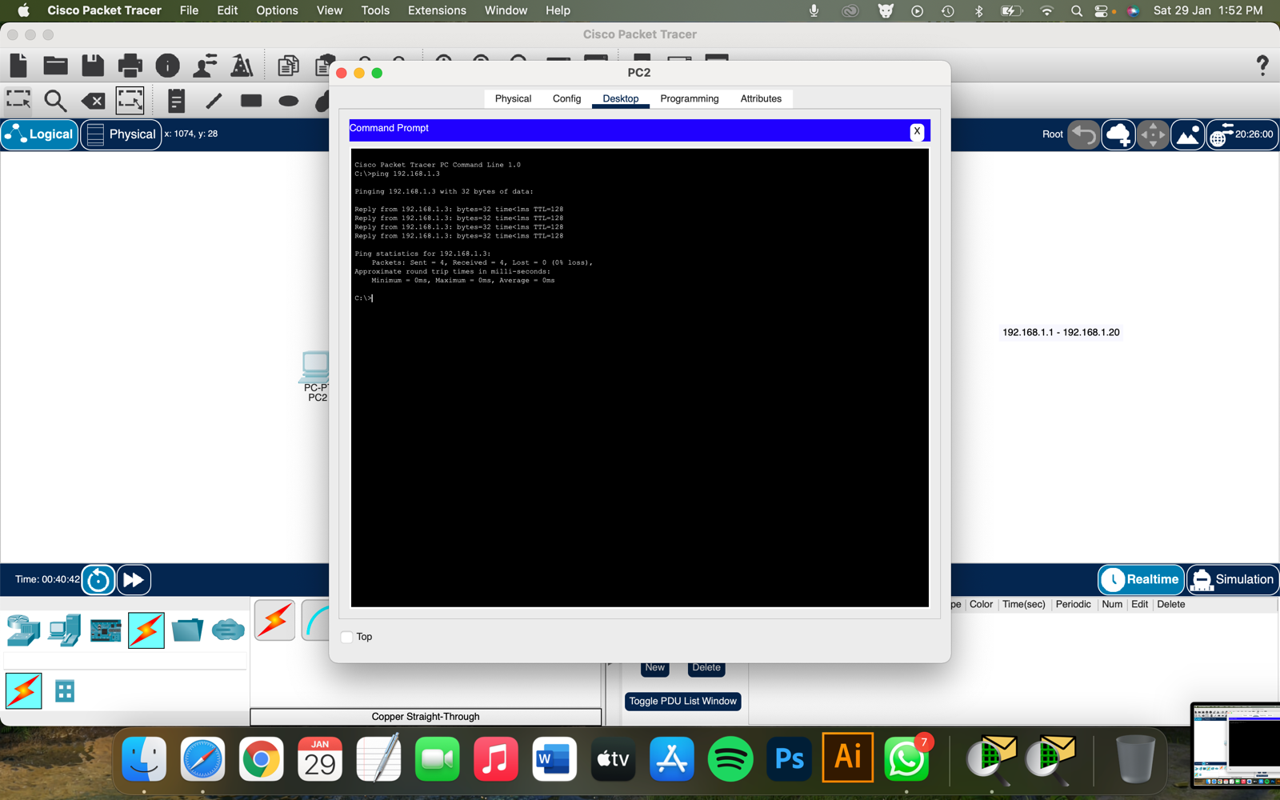



Task 4: Transferring PDU from one PC to another PC through the connection, in simulation mode

Screenshot: 

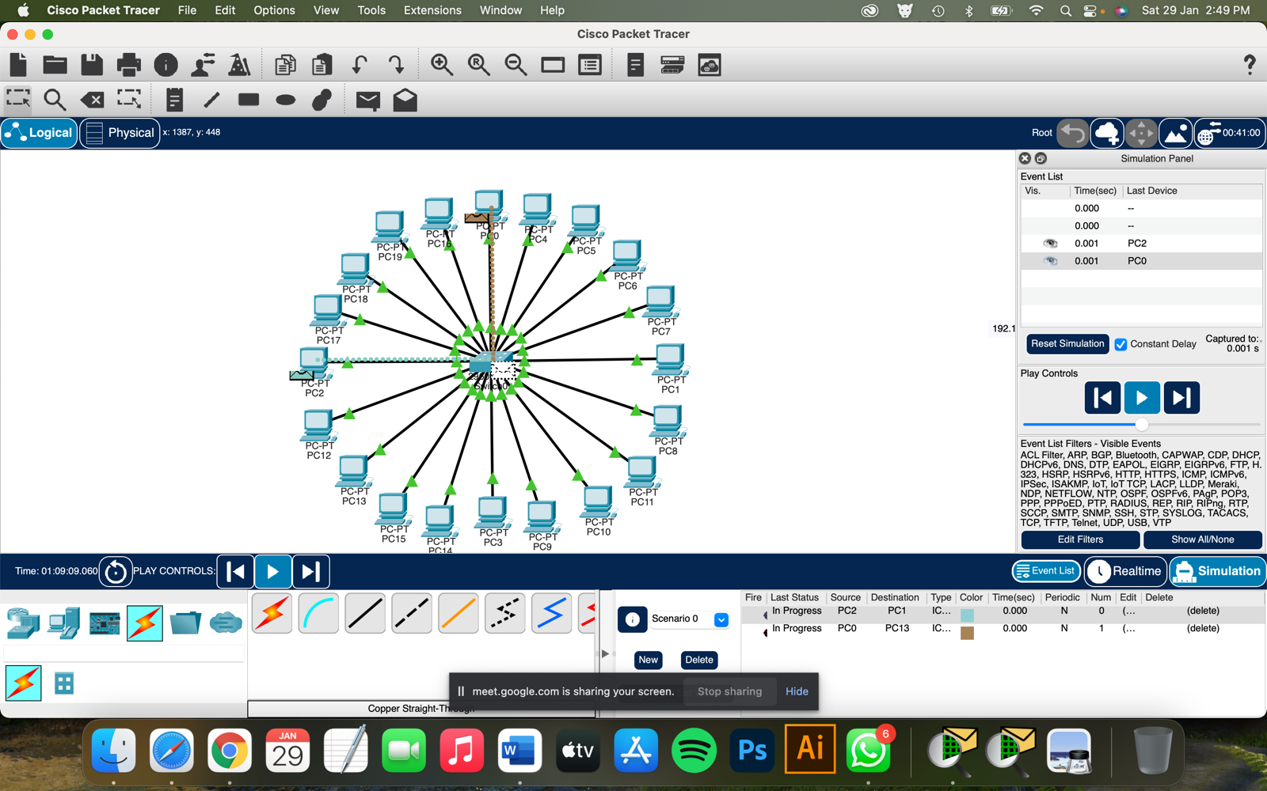

**EXPERIMENT 6**

**Simulation using Packet Tracer with help of router**

Screenshot:

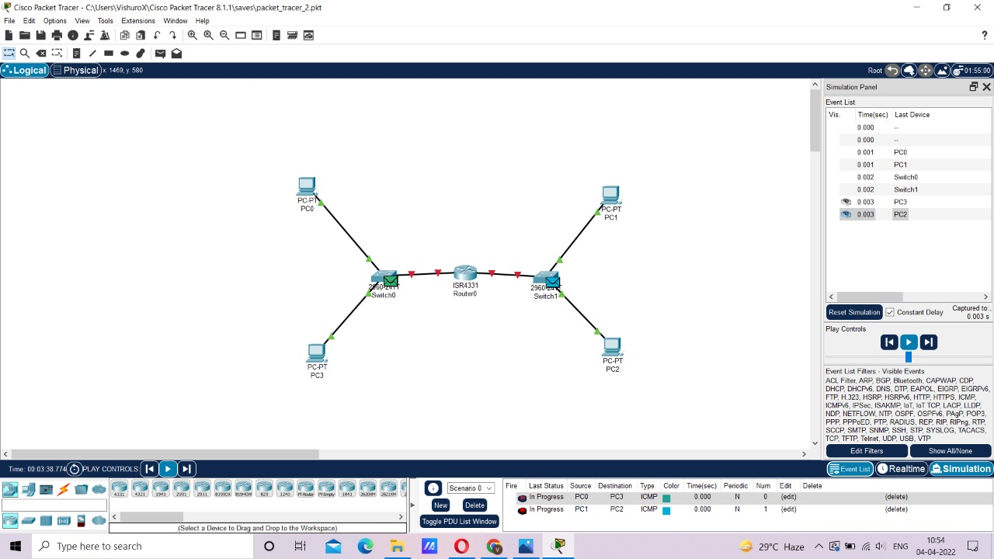

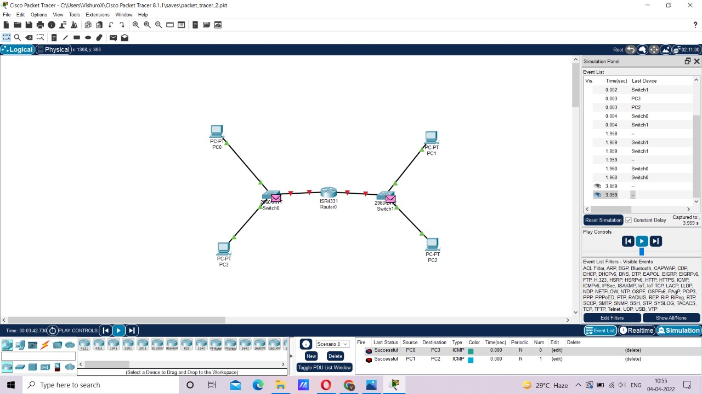

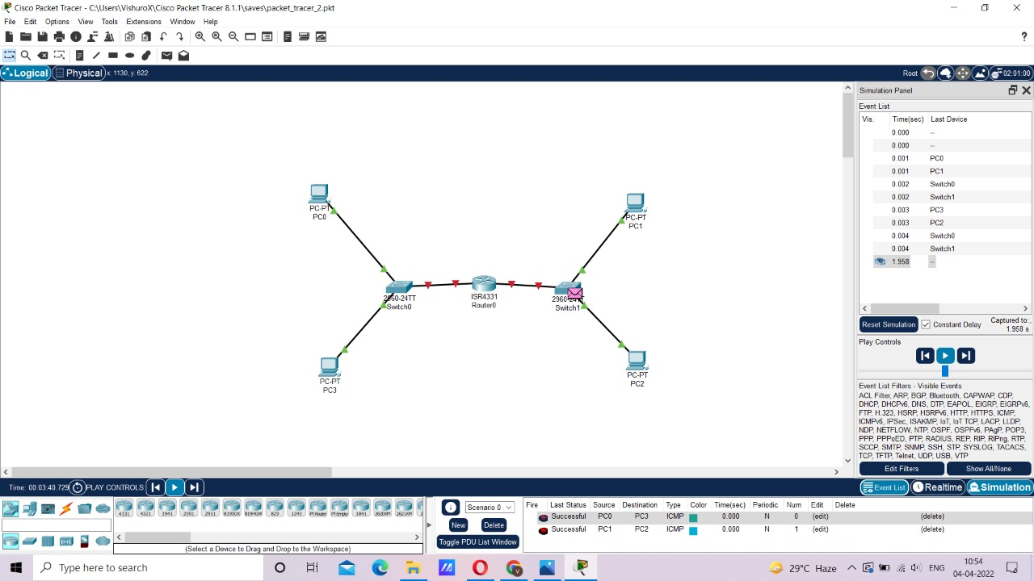

**EXPERIMENT 7**

**Set up network topology using two routers.**

**Screenshot:**

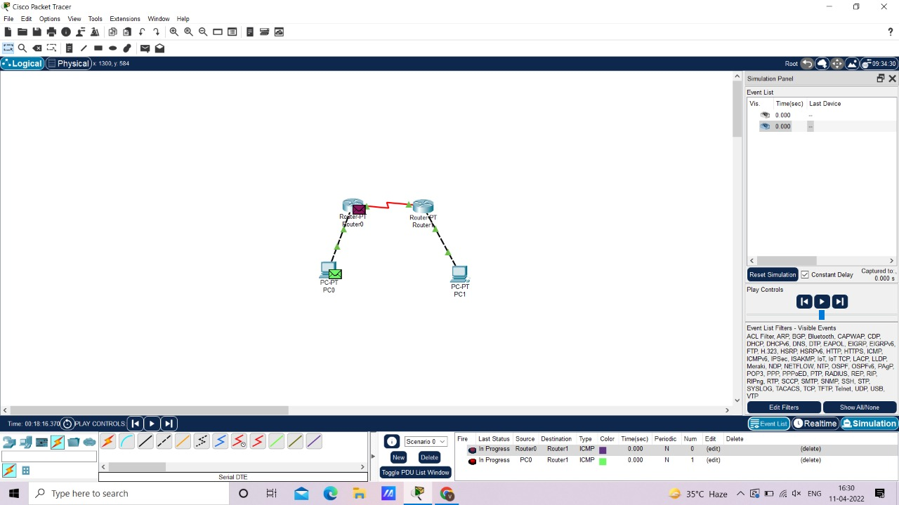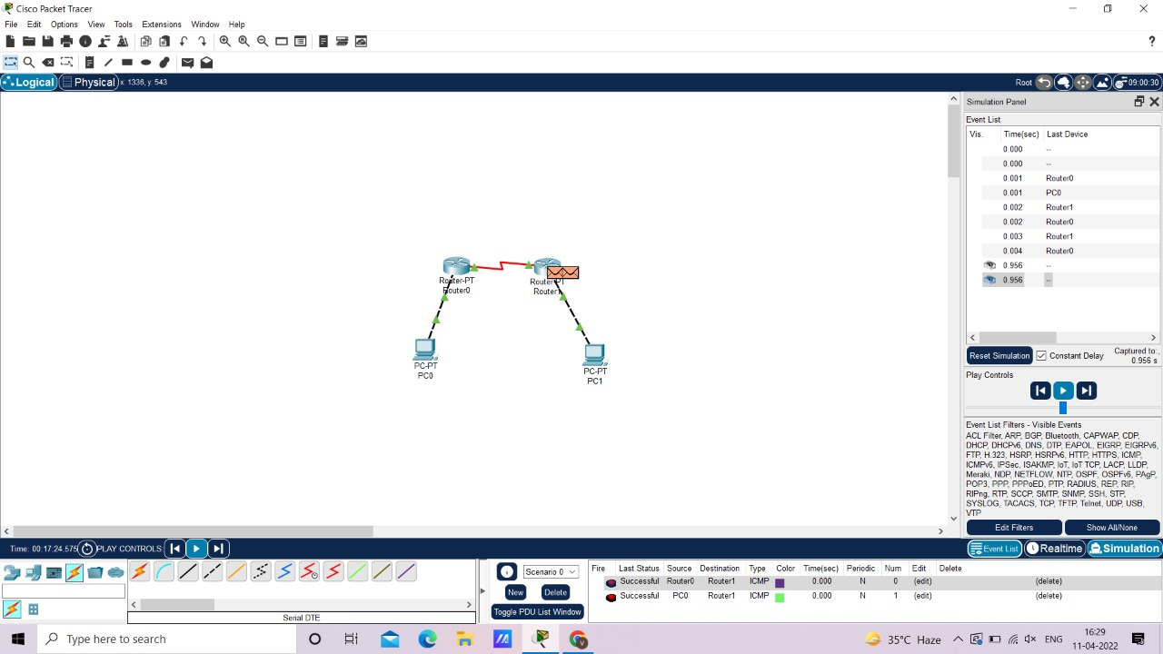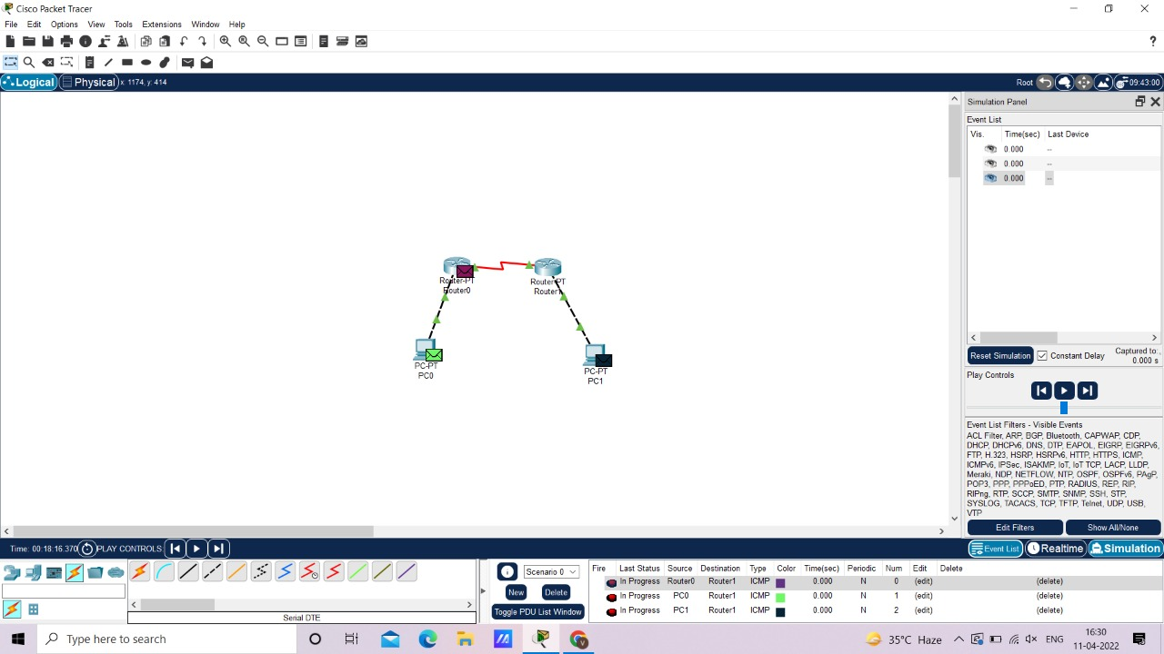

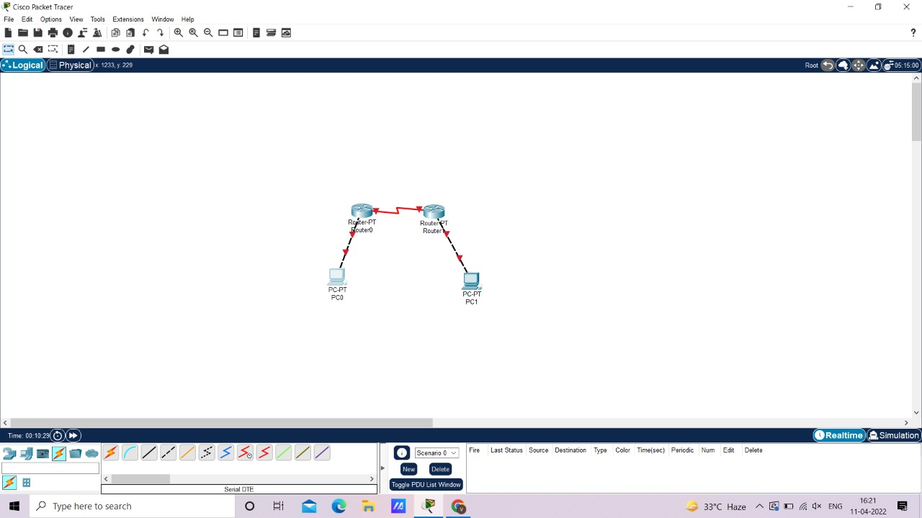

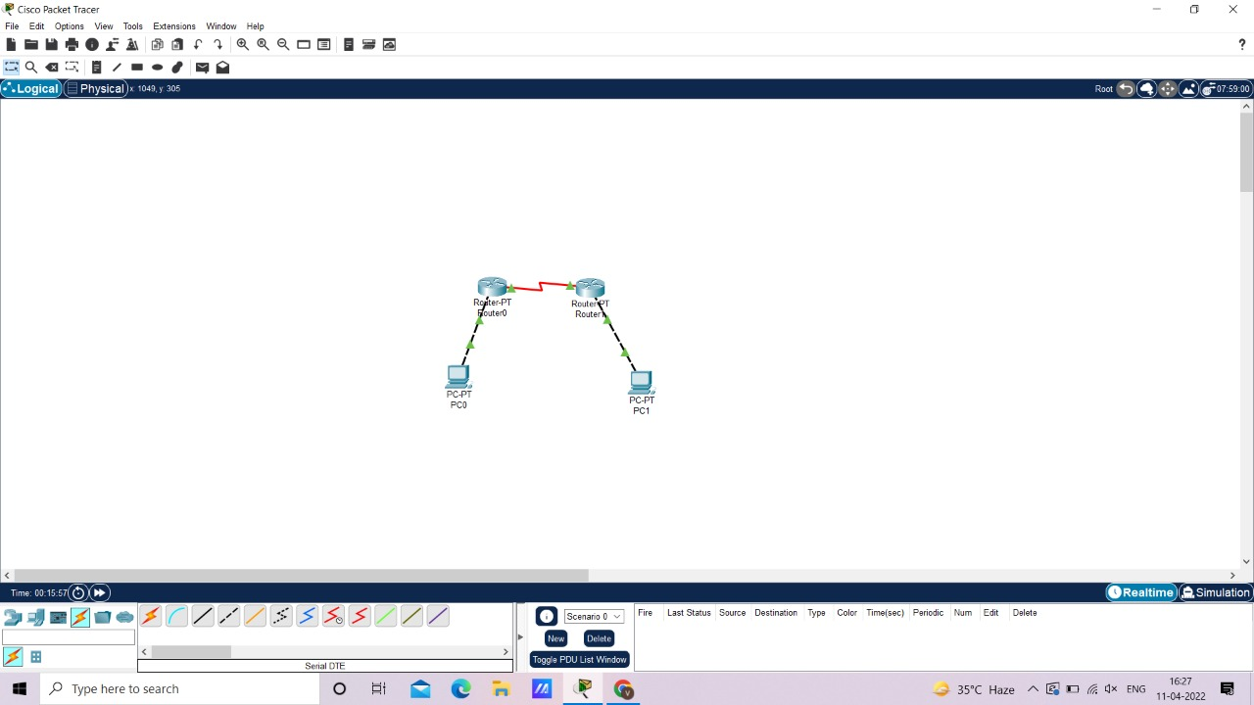

**EXPERIMENT 8**

**Set up network topology using more than two routers**

**Screenshot:**



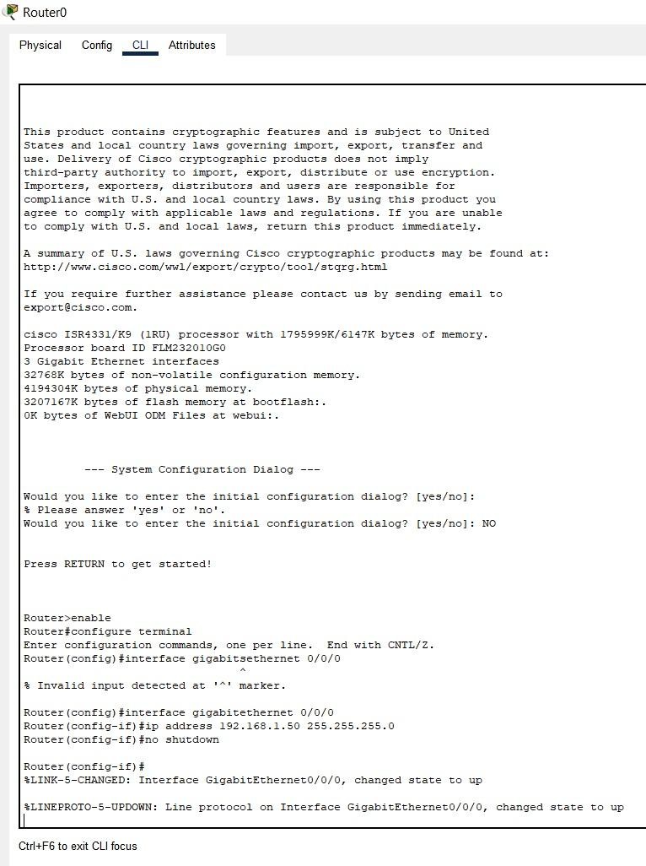

**EXPERIMENT 9**

**IP ADDRESSING**

